7-Point Inspection Checklist for Containers
Date: Supplier: Facility: Container#: Seal#
Inspected by: Is the seal a High Security Seal* Y N
Is the seal affixed properly to the container? Y N
Instructions: Fill out the checklist by referring to the drawing below and the instructions provided on the next page.

Inspection Point | Condition: Indicate whether condition is  good or bad; add comments as needed
1. Outside / Undercarriage
2. Inside and outside doors
3. Right side
4. Left side
5. Front wall
6. Ceiling / roof
7. Floor (inside)
Container reviewed by:
Date/time of review:
Seal reviewed by:
Date/time of review:

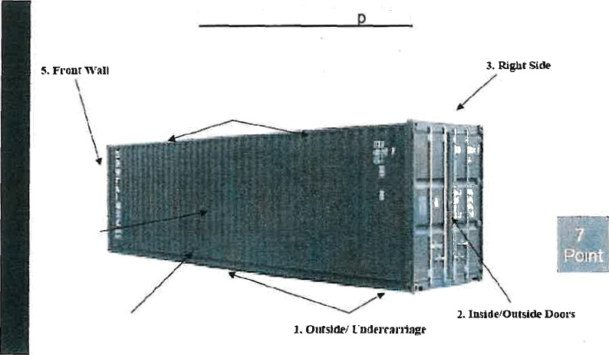
7-Point Container Ins ection
B.CeiUopQoof
7.FDoor(IRsife)



Outside / Undercarriage (before entering facility)
  - Inspect prior to entering facility
  - Support beams should be visible.

Inside / Outside Doors
  - Make sure secure and reliable locking mechanisms are attached to the container.
  - Be on the lookout for different color bonding material.
  - Be on the lookout for loose bolts.
  - Be on the lookout for plates and repairs. Solid plates should not cover standard container cavities.
- Right Side
  - Look for unusual repairs to structural beams
  - Repairs to walls on the inside must be visible on the outside.
  - Use tool to tap side walls. Listen and feel for hollow sound.
- Left Side
  - Look for unusual repairs to structural beams
  - Repairs to walls on the inside must be visible on the outside.
C. Use tool to tap side walls. Listen and feel for hollow sound.
- Front Wall
  - Check to see if blocks and vents are visible.
  - Use tool to tap front wall. Listen and feel for hollow sound.
C. Use a ranger finder, measuring tape, or even string to determine if the I
d. Make sure the length of the interior of the container is correct.

Ceiling / Roof
  - Check to make sure ceiling height from floor is accurate. Blocks and vents should be visible.
  - Repairs to the ceiling on the inside of the container should be visible on the outside.
  - Use tool to tap ceiling. Listen for hollow sound.
  - Determine if there is an uncomfortable feeling inside the container. If so, the interior ceiling height may be incorrect.
- Floor (inside)
  - Check to make sure the floor is the correct height from the ceiling.
  - Make sure the floor is flat. Do not need to step up to get inside.
  - Make sure the floor is a uniform height.
  - Be on the lookout for unusual repairs.

